“Send Me No Flowers”
Hunterdon Hills Playhouse
Thursday, September 17, 2026
Drive yourself or carpool.
Arrive by 11am.
Cost is $90.
Reservations & Payment due August 17th

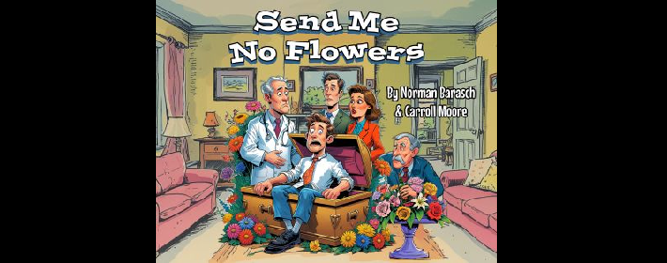

Eastern Upper Bucks Senior Center
8040 Easton Road (Route 611)
PO Box 545 Ottsville, PA 18942
Phone: 610-847-8178 Fax: 610-847-2036
Email: eubseniors@epix.net
Website: easternupperbucksseniorcenter.com

